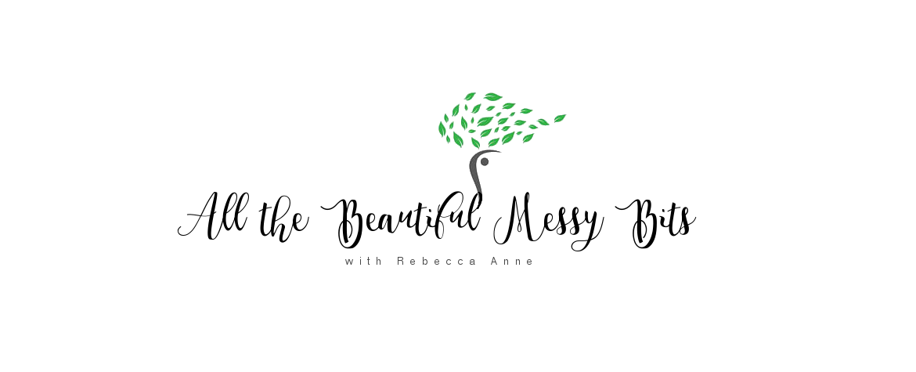
Weekly Class Schedule

All That Matters
128 North Main Street, Providence, RI

Saturdays 8:00-81:15am – Meditation
Meditating with others is great way to anchor your practice and effect change. Session may include simple guidance and/or breathwork. No experience necessary. This is a free community offering.

Saturdays 8:30-9:30am – Yoga I/II
This Yoga I and Yoga II blended class includes key instruction for beginner yogis, while offering options for experienced yogis to deepen and further their practice. Teachers will address various levels while adapting to students’ needs.
All That Matters classes: $16 drop-in or class passes & monthly memberships available.

